Compile correctly | 5
Design of the problem solution | 10
Code written in a package and is modularized | 10
Is the code appropriately documented | 10
Variable naming | 10
Appropriate exception handling | 10
Is the system easy to run | 5
Can the code be rerun without duplication of transactions | 10
Can the code be run for any date | 10
Is the minimum amount handled correctly | 10
Professional Presentation | 10
Deskbank file, is it correct | 40
Daily banking report, run it for various days, does it work | 20
Fraud report, did it pick up the invalid card values | 10
Was the RUN_TABLE created, does it work | 15
Was the email with attachment sent | 15
TOTAL
Xudong.Liu@student.uts.edu.au
100

Comments
ID: U12020830
You did an excellent job with your design document. A small criticism though is that you did not explain HOW each module performs its function. You say what it does but you need to say HOW also. Your fraud description is very good. Don’t be scared to include the sql statements in the design document which the developer could use.
The approach and presentation is first class and I am sure that the rest will come with experience and practice and for now you have a very good grounding.

Ran the program, all the files were created as expected and the email arrived. I can’t ask for a better result. Perfect!

Tried to run again. The run table control is great.
Let me force the run now. Not part of the spec but I want to see what happens

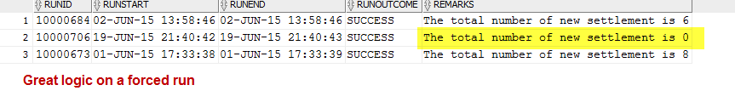

Your program behaves perfectly. Very well done

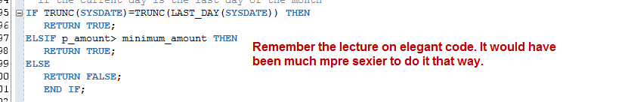

Code looks very good.

I can not fault you. Your commenting of the package and the modules is exemplary. The code looks great. Exception handling and logging is first class.

I am very impressed. Very well done.

Keep this up and I am sure you will be one of the gun developers.

